Total Team Training

Presented By
Brian Gillis / Owner and Guide
Results-Learning Works Best When Ongoing
YouNetResuIts.com / 678-910-1401
brian.gillis@younetresults.com

Table of Contents

Opening Thoughts 1
You Net Results — Language 2
Lotus Code 3
Only Two Ways to Increase Sales 4
Left Hand Right Hand 5
Notes Page 6
Full System Isolation 7
Full System Isolation Continued 8
Preventative Maintenance Inspection 9
Preventative Maintenance Inspection Continued 10
Vehicle Intake Form 11
Looking Through the Customers Lenses 13
Transolution Bid Sheet 14
Notes Page 17
Full System Isolate (Initial Concern) Presentation Script 19
PMI (Additional Concerns) Presentation Script 20
Notes to Self 22

.

Opening Thoughts

Advisor Results Academy
Presenting

Total Team Training
Featuring

Results-Learning that Grows Your Confidence
This not a lecture or a speech, it’s a virtual clinic. A hands-on, participation by all, voice, mind and body workshop. Old habits are hard to break, new ones are hard to learn, and sometimes we don't want to do either.

Advisor Results Academy believes you have to learn it, use it, teach it and own it. That's our goal for our time together.

Brian Gillis has over three decades of experience working in the automotive industry, including owning and managing multiple shops. In these Virtual Clinic sessions, Brian works with your Service Advisors and Technicians to create the smoothest possible key-to-key experience for customers.

When your team knows how to run every system, your shop will run like a well-oiled machine, and your cash register will ring like never before!

You Net Results — Language

- Yes ___________________________________________________________________________________
- SOS ___________________________________________________________________________________
- Professional Obligation __________________________________________________________________
- Stop Selling Your Own Wallet _____________________________________________________________
- Buying Mood __________________________________________________________________________
- Most Important Customer ________________________________________________________________
- Lotus Code _____________________________________________________________________________
- ECM __________________________________________________________________________________
- Two Ways to Increase Sales _______________________________________________________________
- Full System Isolate ______________________________________________________________________
- PMI __________________________________________________________________________________
- Eyes on it _____________________________________________________________________________
- Intake Sheet ___________________________________________________________________________
- Bid Sheet ______________________________________________________________________________
- PARP _________________________________________________________________________________
- The Customers Lenses ___________________________________________________________________

Lotus Code

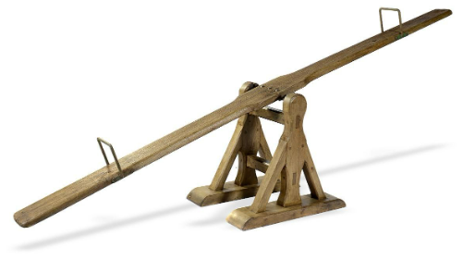
What is it? ____________________________________________________________________

- T____________________________________________________________________________________________________________________________________________________________________
- W___________________________________________________________________________________________________________________________________________________________________
- A____________________________________________________________________________________________________________________________________________________________________
- H____________________________________________________________________________________________________________________________________________________________________
- P____________________________________________________________________________________________________________________________________________________________________
- A____________________________________________________________________________________________________________________________________________________________________
- Other Thoughts: ____________________________________________________________________________________________________________________________________________________________________________________________________________________________________________________________________________________________________________________________________________________________________________________________________________________________________________________________________________________________________________________________________

Only Two Ways to Increase Sales

A. | B.

Left Hand Right Hand

Describe a situation you encountered, as a consumer, where you felt the left hand didn’t know what the right hand was doing?
_______________________________________________________________________________________________________________________________________________________________________________________

How did that make you feel? _____________________________________

What do you believe is the answer to avoiding this situation? _______________________________________________________________________________________________________________________________________________________________________________________

Notes Page
____________________________________________________________________________________________________________________________________________________________________________________________________________________________________________________________________________________________________________________________________________________________________________________________________________________________________________________________________________________________________________________________________________________________________________________________________________________________________________________________________________________________________________________________________________________________________________________________________________________________________________________________________________________________________________________________________________________________________________________________________________________________________________________________________________________________________________________________________________________________________________________________________________________________________________________________________________________________________________________________________________________________________________________________________________________________________________________________________________________________________________________________________________________________________________________________________________________________________________________________________________________________________________________________________________________________________________________________________________________________________________________________________________________________________________________________________________________________________________________________________________________________________________________________________________________________________________________________________________________________________________________________________________________________________________________________________________________________________________________________________________________________________________________________________________________________________________________________________________________________________________________________________________________________________________________________________________________________________________________________________________________________________________________________________________________________________________________________________________________________________________________________________________________________________________________________________________________________________________________________________________________________________________________________________________________________________________________________________________________________________________________________________________________________________________________________________________________________________________________________________________________________________________________________________________________________________________________________________________________________________________________________________________________________________________________________________________________________________________________________________________________________________________________________________________________________________________________

Full System Isolation

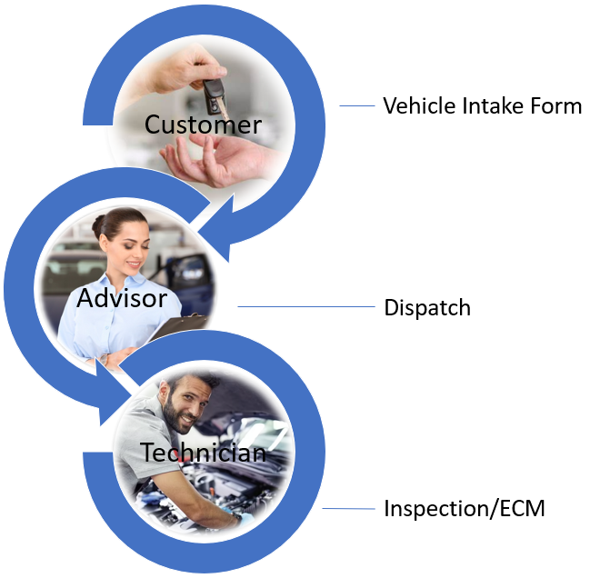

Notes: _____________________________________________________________________________________________
____________________________________________________________________________________________________
____________________________________________________________________________________________________
____________________________________________________________________________________________________
____________________________________________________________________________________________________
____________________________________________________________________________________________________

Full System Isolation Continued

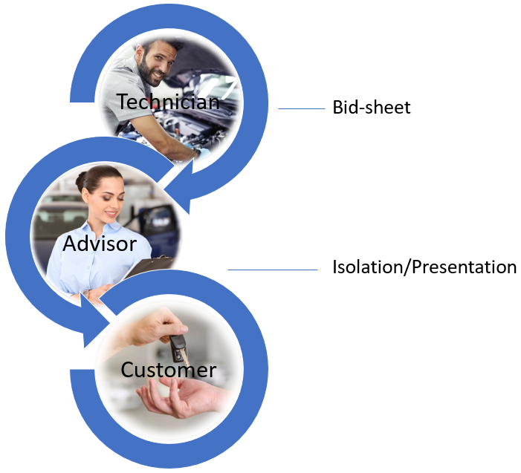
Notes: _____________________________________________________________________________________________
____________________________________________________________________________________________________
____________________________________________________________________________________________________
____________________________________________________________________________________________________
____________________________________________________________________________________________________
____________________________________________________________________________________________________
____________________________________________________________________________________________________

Preventative Maintenance Inspection

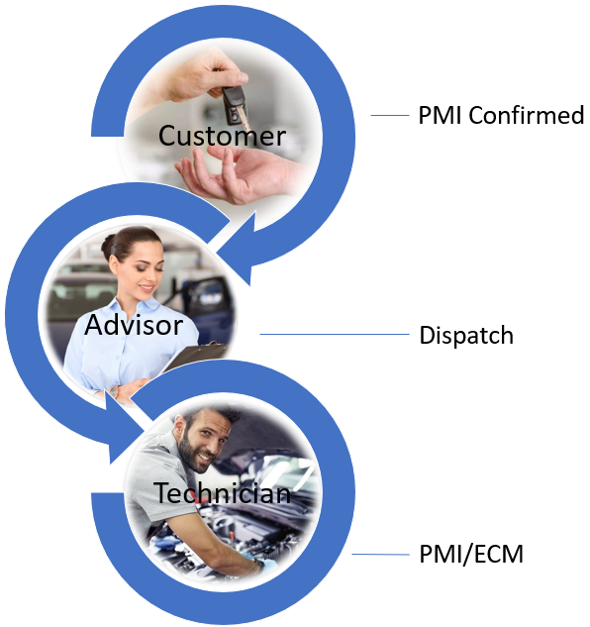

Notes: _____________________________________________________________________________________________
____________________________________________________________________________________________________
____________________________________________________________________________________________________
____________________________________________________________________________________________________
____________________________________________________________________________________________________
____________________________________________________________________________________________________
____________________________________________________________________________________________________

Preventative Maintenance Inspection Continued

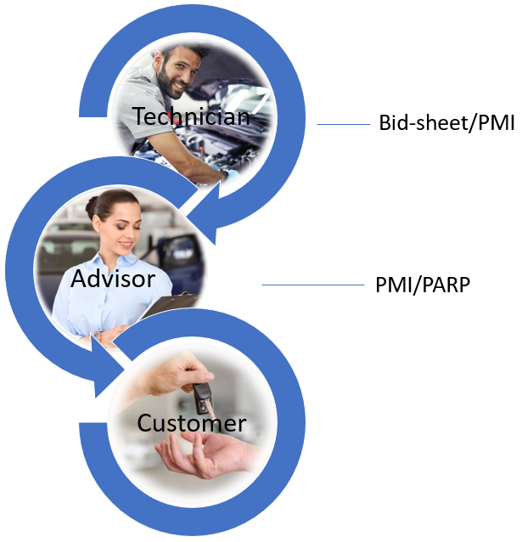

Notes: _____________________________________________________________________________________________
____________________________________________________________________________________________________
____________________________________________________________________________________________________
____________________________________________________________________________________________________
____________________________________________________________________________________________________
____________________________________________________________________________________________________
____________________________________________________________________________________________________

Vehicle Intake Form
4500 TRANSOLUTION LN  MISSOULA MT 59804  406-721-6109  WWW.TRANSOLUTION.BIZ |  |  | FOR OFFICE USE ONLY
 |  |  | APPOINTMENT
 |  |  | DATE |  |  |  |  | DAY |  | TIME
 |  |  | NEW CUSTOMER  Y / N |  |  | If YES HOW DID CUSTOMER HEAR ABOUT US?
CUSTOMER NAME |  |  | SERVICE ADVISOR
STREET ADDRESS |  |  | VIN
CITY | STATE | ZIP CODE | LICENSE NUMBER |  |  |  |  |  | EXT. COLOR/TRIM
BUSINESS PHONE | HOME OR CELL PHONE |  | PRODUCTION DATE |  | TRANSMISSION  A / M |  |  |  | AIR CONDITIONING  Y / N |  | □ 4X4  □ AWD
EMAIL ADDRESS |  |  | MILEAGE |  |  |  |  |  | ENGINE SIZE
VEHICLE YEAR | VEHICLE MAKE AND MODEL |  |  |  |  | THIS VEHICLE IS USED FOR TOWING  □ YES □ NO

Please describe in your own words any problems/concerns you are having with your vehicle:

CHOOSE ONE:  - I request a verbal estimate before you begin repairs.  - I approve communication via text.  - Proceed with repairs but contact me if the price will exceed $ .  SAVE PARTS? YES □ NO □ | Thank you for taking the time to fill out this form completely.
Please take time to review terms on reverse side before signing!
DATE SIGNATURE
SUBJECT TO TERMS ON REVERSE SIDE

NOTICE TO THE CUSTOMER
- The preliminary estimate is based on our initial inspection and diagnosis. If any additional service and repairs are indicated, you will be contacted for your authorization. All work is to standard of good and workmanlike under Automotive Service Excellence (ASE) guidelines.
We do our best to obtain an accurate initial inspection and diagnosis, and it is subject to a non-refundable charge. There may be some situations where a greater amount of inspection and diagnosis calls for disassembling of the automotive component for further inspection and our recommendation. Please take the time with us to fully describe your motor vehicle's history and use so that we may assess your problem.

- All replacement parts installed are new or remanufactured and provided by automotive parts suppliers or manufacturer, unless otherwise specified.
- All parts removed will be discarded unless otherwise instructed.
- Any limited warranties on the replacement parts and/or accessories are those made by manufacturer, the automotive parts firm, or the parts jobber for rebuilt/reconditioned parts. Generally, the replacement part is warrantied by the manufacturer or the automotive parts firm for one year and the benefit of the warranty is a replacement part, excluding labor to remove and install.
TRANSOLUTION AUTO CARE HERBEY EXPRESSLY DISCLAIMS ALL OTHER WARRANTIES, EXPRESS OR IMPLIED, INCLUDING ALL IMPLIED WARRANTIES OF
MERCHANTABILITY OR FITNESS FOR A PARTICULAR PURPOSE. Transolution Auto Care must be contacted for any limited warranty work, including requirements for replacement parts. This limited warranty will not be honored if the customer seeks replacement of the part, or service work at or through another automotive facility. The reason we insist on the return of the motor vehicle to Transolution Auto Care is that we have learned of your motor vehicle through our inspection and diagnosis, followed by our repairs. We take pride in our work and will do all that we can to service your needs. Please be mindful, however, that we cannot prioritize your work ahead of other emergencies. Nonetheless, we will do all we can to promptly advise you of the status of your motor vehicle, and what is required for service and repairs.

- All service work, meaning labor at our shop rate, has a limited warranty of 24,000 miles or two years from date of service, whichever occurs first, unless malfunction or failure is caused by abuse, misuse of the motor vehicle, or physical damage to the motor vehicle caused by another party such as a motor vehicle collision, vandalism, fire, flood, or other casualties. For any claim against the limited warranty, all service work must be performed at Transolution Auto Care and all replacement parts must be obtained by Transolution Auto Care as well. (This is necessary because we are familiar with the manufacturers, automotive parts firms, and jobbers that supply replacement parts.)

- Major automatic transmission repair/replacement will be identified as such on your estimate. Major automatic transmission repair and replacement will be protected by a different warranty than this limited warranty. There is an Automotive Transmission Rebuilders Association
(ATRA) warranty that will be provided to you upon completion of the work. All warranty work on the automatic transmission repair/replacement must
be performed by Transolution Auto Care, an ATRA authorized facility.

- A shop supplies and disposal charges will be added to the repair order.

- Customer grants Transolution Auto Care permission to operate the motor vehicle on public streets and highways for purposes of testing, inspection and diagnosis. Please deliver you motor vehicle with sufficient fuel to operate it. If, during an inspection and diagnostic test drive we must purchase fuel for your motor vehicle, there will be an additional $10 labor charge, together with the cost of the fuel that will be added to the final invoice.

- Storage charge will commence 72 hours after service and repairs are completed. Storage charges are $10 per day.

- A motor vehicle will be assumed "abandoned" if left upon Transolution Auto Care property for ninety (90) days. Transolution Auto Care reserves all rights to hold property left with Transolution Auto Care under an Agister's Lien until all storage charges and repair and service costs are paid in full, under Mont. Code Ann., 71-3-1201-1214 (2015).

- By acceptance of the inspection and diagnosis, there is authorization for the necessary service and repair work that we have itemized for you. Transolution Auto Care is not responsible for loss of personal property, articles and possessions the customer leaves in the car, whether by theft, fire, flood, or other casualty.
TRANSOLUTION AUTO CARE IS NOT RESPONSIBLE FOR ANY DELAYS CAUSED BY UNAVAILABILITY OF PARTS, OR DELAYS IN PARTS SHIPMENT BY THE MANUFACTURER OR AUTOMOTIVE PARTS FIRMS. TRANSOLUTION AUTO CARE IS NOT RESPONSIBLE FOR ANY INCIDENTAL OR CONSEQUENTIAL DAMAGES DUE TO CUSTOMER'S LOSS OF USE OF MOTOTR VEHICLE.

- In the event that any legal action becomes necessary to enforce any terms of the contract for service and repairs, evidenced by the written estimate, invoice, and this Limited Warranty and Notice to Customer, the prevailing party shall also be responsible for all reasonable attorney's fees and Court costs incurred.

Looking Through the Customers Lenses

Sometimes we see things from our own perspective; however, we must always remember, it’s our professional obligation to present EVERYTHING the vehicle is in need of. The fact that the word “need” is subjective is the reason, ALWAYS remember to look through the customers lenses!

Let’s have a discussion:

Transolution Bid Sheet

Estimate of Recommended Repairs
Transolution
Cust Name: RO #: Tech: Date / /

Labor Description (what): | Parts:
Labor Time =
WHY?

Labor Description (what): | Parts:
Labor Time =
WHY?

Labor Description (what): | Parts:
Labor Time =
WHY?
See Reverse for Additional Estimates (OVER)

Labor Description (what): | Parts:
Labor Time =
WHY?

Labor Description (what): | Parts:
Labor Time =
WHY?
Labor Description (what): | Parts:
Labor Time =
WHY?

Maintenance Items by System

Select a failed part, pick a system on the vehicle and list as many maintenances within that system.

Failed part: ___________________________________________________________

Maintenance items within failed system:

How do we identify maintenance needs?
List methods used to determine vehicles maintenance needs:

Notes Page
____________________________________________________________________________________________________________________________________________________________________________________________________________________________________________________________________________________________________________________________________________________________________________________________________________________________________________________________________________________________________________________________________________________________________________________________________________________________________________________________________________________________________________________________________________________________________________________________________________________________________________________________________________________________________________________________________________________________________________________________________________________________________________________________________________________________________________________________________________________________________________________________________________________________________________________________________________________________________________________________________________________________________________________________________________________________________________________________________________________________________________________________________________________________________________________________________________________________________________________________________________________________________________________________________________________________________________________________________________________________________________________________________________________________________________________________________________________________________________________________________________________________________________________________________________________________________________________________________________________________________________________________________________________________________________________________________________________________________________________________________________________________________________________________________________________________________________________________________________________________________________________________________________________________________________________________________________________________________________________________________________________________________________________________________________________________________________________________________________________________________________________________________________________________________________________________________________________________________________________________________________________________________________________________________________________________________________________________________________________________________________________________________________________________________________________________________________________________________________________________________________________________________________________________________________________________________________________________________
Broke Car Scenario/ECM
Before the Advisor presents to the customer, the technician must first present to the Advisor. This is where the first sale takes place. Below are helpful hints to help present a failure from Technician to Advisor.

Technicians, role play a presentation using a “Broke Care Scenario”.

Scenario “Vehicle Symptom”: ________________________________________________________________ _________________________________________________________________________________________
_________________________________________________________________________________________

Describe the failure: ________________________________________________________________________
__________________________________________________________________________________________________________________________________________________________________________________

What failed? ______________________________________________________________________________
_________________________________________________________________________________________

How does it function? ______________________________________________________________________
___________________________________________________________________________________________________________________________________________________________________________________________________________________________________________________________________________

If not addressed what could happen? _________________________________________________________
__________________________________________________________________________________________________________________________________________________________________________________

E: _______________________________________________________________________________________
_________________________________________________________________________________________

C: _______________________________________________________________________________________
_________________________________________________________________________________________

M: ______________________________________________________________________________________
_________________________________________________________________________________________

Full System Isolate (Initial Concern) Presentation Script

Mr./Mrs. _____________ this is ____________ from _____________ is now a good time
(Customers Name) (Your name) (Shop Name)
to talk? If the answer is “No”…responding with…When is a good time to call you back?

If the answer is “Yes”…respond with …Great!

My ASE technician _______________ and I have personally inspected _____________
(F&B) (Tech’s first name) (Credibility) (Mirror back concern as the customer stated)

And have taken digital photo graphs and or a video for your records as well.

Over all the _________________ is in Great Shape. (If it truly is)
(System being addressed only)

List Three Positive of The Particular System We are Addressing:
(All for reassurances)

The ___________________ is in ________shape, (choose the proper wordage, normal,
(Insert word) excellent, not leaking, good, great,
condition, satisfactory)
The ___________________ is in ________shape, (Blend in with failure explanation)
(Insert word)

The ___________________ is in ________shape,
(Insert word)
We have isolated your concern and identified these items needing immediate attention (Deliver with Urgency and Conviction!) Be prepared to explain functionality of fail component(s), along with ECM.

Failure _____________________________________________________________________
Effect ______________________________________________________________________
Cause ______________________________________________________________________
Maintenance _________________________________________________________________

Again, overall the __________________________ is in Great Shape! (Reassurance)
(System being addressed)
Your total investment for this repair is $ ______________ dollars (include all taxes and ad on fees),

This repair has a _____ year - _____ miles Nationwide Guarantee. (Or insert Guarantee this repair has)
(F & B and Reassurance)
So, with your permission I’ll have __________________________ get started on the repairs.
(Do not pause keep pushing through) (Insert tech’s first name)
Is this a good number to reach you periodically throughout the day with update ____ (wait for the answer)

Once the repair is completed and your vehicle is road tested. I’ll have _______ to perform a complimentary maintenance inspection, to make sure the rest of the vehicle is in safe and operating order. (This can be delivered during an update or with the Isolation presentation)

Thank you – I will be talking with you soon. (Always assume the customer wants it fixed!!!

PMI (Additional Concerns) Presentation Script

Mr. / Mrs._____________________ this is ____________ from ______________ is now a good
(Insert customers name) (Your Name) (Insert Shop Name)
time to talk? If the answer is "No"... responding with... When is a good time to call you back?
If the answer is "yes". . . respond with. . . Great!

The repairs on your ____________ have been completed and we don't see any other
issues with this repair at this time! (Make sure nothing else is needed before you proceed)

As promised my ASE Technician __________________ and I have personally completed the
Preventive Maintenance Inspection on your vehicle and have taken digital photographs of your vehicle. Overall, your vehicle is in great shape (if it truly it is).

First: We started with the test drive and under-hood inspection.

We have inspected _______________________ and it was in great shape.
We have inspected _______________________ and looks like it was recently replaced.
We have identified your _______________________ is due by milage.
We have inspected _______________________ and it was in great shape.
We have identified your _______________________ are bad and they need to be replaced.
We're also going to_______________________ and _____________________________.

Additional Notes: ______________________________________________________
______________________________________________________________________________

Second: We performed a mid-rise inspection and identified the following:
We have inspected _______________________ and it looks good.
We have inspected _______________________ and they have ___ /32nds of tread.
We have identified your _______________________ are worn out and they need to be monitored.
We have inspected _______________________ and it was in great shape.
We have identified your ________________________are bad and they need to be replaced.
We're also going to_______________________ and _____________________________.

Additional Notes: ______________________________________________________
___________________________________________________________________

Third: We completed the full rise inspection and identified the following:
We have inspected _______________________ and it was in satisfactory shape.
We have inspected _______________________ and it was in great shape.
We have identified your _______________________ are bad and they need your immediate attention.
We have inspected _______________________ and it is free of leaks.
We have identified your _______________________ are bad and they need to be replaced.
We're also going to_______________________ and _____________________________.

Additional Notes: ______________________________________________________
___________________________________________________________________

Overall, your _______________________ is in Fine Shape!
(Insert vehicle Type)

These additional repairs also have the _________ month – __________ miles Nationwide guarantee.

Your additional investment today is $ ____________ dollars which brings your total investment to $ ___________ and this includes all taxes and fees.

Again, your vehicle is well worth the investment (if it is), so with your permission I will have
___________________ started on the additional repairs. (Do not pause keep pushing through)

Is this still the best number to reach you?

Great, I'll give you a call once your vehicle has been road tested and completed.

Additional Notes: ___________________________________________________________________________
____________________________________________________________________________________________________________________________________________________________________________________

lease Share Your Feedback

What did you learn? ____________________________________________________________________
_____________________________________________________________________________________
_____________________________________________________________________________________
_____________________________________________________________________________________

What was you’re your biggest takeaway? ____________________________________________________
_____________________________________________________________________________________
_____________________________________________________________________________________
_____________________________________________________________________________________

What was your largest “aha” moment? ______________________________________________________
_____________________________________________________________________________________
_____________________________________________________________________________________
_____________________________________________________________________________________

What will you take back and use during your next work day? ____________________________________
_____________________________________________________________________________________
_____________________________________________________________________________________
_____________________________________________________________________________________

If there was one thing you would change to make the ARA Front Counter Workshop experience better
for you, what would it be? _______________________________________________________________
_____________________________________________________________________________________
_____________________________________________________________________________________
_____________________________________________________________________________________

For fresh new content, please subscribe to my channel and follow me on Facebook !
Search You Net Results.
Please Share Your Feedback

What did you learn? ____________________________________________________________________
_____________________________________________________________________________________
_____________________________________________________________________________________
_____________________________________________________________________________________

What was you’re your biggest takeaway? ____________________________________________________
_____________________________________________________________________________________
_____________________________________________________________________________________
_____________________________________________________________________________________

What was your largest “aha” moment? ______________________________________________________
_____________________________________________________________________________________
_____________________________________________________________________________________
_____________________________________________________________________________________

What will you take back and use during your next work day? ____________________________________
_____________________________________________________________________________________
_____________________________________________________________________________________
_____________________________________________________________________________________

If there was one thing you would change to make the ARA Front Counter Workshop experience better
for you, what would it be? _______________________________________________________________
_____________________________________________________________________________________
_____________________________________________________________________________________
_____________________________________________________________________________________

For fresh new content, please subscribe to my channel and follow me on Facebook !
Search You Net Results.

Notes to Self
What did you learn? ________________________________________________________________________________ _________________________________________________________________________________________________ _________________________________________________________________________________________________
What was you’re your biggest takeaway? ________________________________________________________________ _________________________________________________________________________________________________ _________________________________________________________________________________________________
What was your greatest “aha” moment? _________________________________________________________________ __________________________________________________________________________________________________ __________________________________________________________________________________________________ __________________________________________________________________________________________________
How can the items you learned today help increase your paycheck? ___________________________________________ __________________________________________________________________________________________________ __________________________________________________________________________________________________
What will you take back and use during your next work day? ________________________________________________ __________________________________________________________________________________________________ __________________________________________________________________________________________________

